Assignment VCS

Assignment

Exercise 1. Create your first Commit.

* Initialize your Repository: git init project Exercise-1
* Create a file with name index.html
* Write code in newly created file
* Stage index.html
* Commit with message ‘Initial Message.’

Solution:

* Initialize your Repository: git init project Exercise-1

* Create a file with name index.html

* Write code in newly created file

* Stage index.html

* Commit with message ‘Initial Message.’

Github:

Assignment

Exercise 2. Commit only one file

* Initialize your Repository
* Create a files with names index.html and about.html
* Add code in both files.
* Stage only one file.
* Commit with message: ‘File x added.’

Solution:

* Initialize your Repository

* Create a files with names index.html and about.html

* Add code in both files.

* Stage only one file.

* Commit with message: ‘File x added.’

Using Github:

Assignment

Exercise 3. Merge branch (No Conflicts).

* Initialize your Repository
* Create index.html file add some code.
* Make Commit.
* Create new branch from master branch with name my-feature.
* Add about-us.html file with code and commit changes in myfeature branch.
* Now checkout master branch.
* Merge my-feature branch into master.

Solution:

* Initialize your Repository

* Create index.html file add some code.

* Make Commit.

* Create new branch from master branch with name my-feature.

* Add about-us.html file with code and commit changes in myfeature branch.

* Now checkout master branch.

* Merge my-feature branch into master.

Using github repo:

* Initialize your Repository

* Create index.html file add some code.

* Make Commit.

* Create new branch from master branch with name my-feature.

* Add about-us.html file with code and commit changes in myfeature branch.

* Now checkout master branch.

* Merge my-feature branch into master.

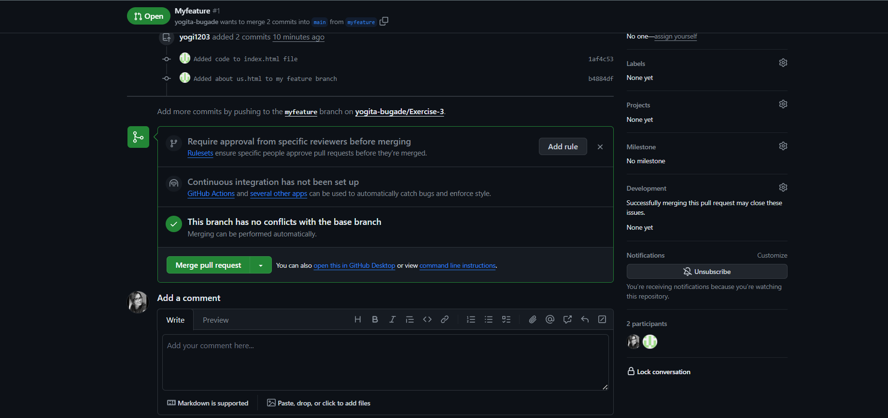

Assignment

Exercise 4. Merge branch (Conflicts).

* Initialize your Repository
* Create index.html file add some code.
* Make Commit.
* Create new branch from master branch with name my-feature.
* Add about-us.html file with code
* Make changes in index.html
* Commit changes in my-feature branch.
* Now checkout master branch.
* Do some code changes in index.html
* Commit changes.
* Now merge my-feature branch into master.
* You will get conflicts for index.html file. Resolve conflict by selecting both changes for the same index.html file.

Solution:

* Initialize your Repository

* Create index.html file add some code.

* Make Commit.

* Create new branch from master branch with name my-feature

* Add about-us.html file with code

* Make changes in index.html

* Commit changes in my-feature branch.

* Now checkout master branch.

* Do some code changes in index.html

* Commit changes.

* Now merge my-feature branch into master.

* You will get conflicts for index.html file. Resolve conflict by selecting both changes for the same index.html file.

Using Github:

• Initialize your Repository

• Create index.html file add some code.

• Make Commit.

• Create new branch from master branch with name my-feature.

• Add about-us.html file with code

• Make changes in index.html

• Commit changes in my-feature branch.

• Now checkout master branch.

• Do some code changes in index.html

• Commit changes.

• Now merge my-feature branch into master.

• You will get conflicts for index.html file. Resolve conflict by selecting both changes for the same index.html file.

